|  |  |  |  |  |  |  |  |  |  |  |  |  |  |  |  |  |  |  |  |  |  |  |  |  |
| --- | --- | --- | --- | --- | --- | --- | --- | --- | --- | --- | --- | --- | --- | --- | --- | --- | --- | --- | --- | --- | --- | --- | --- | --- |
| **FAKULTI TEKNOLOGI MAKLUMAT DAN KOMUNIKASI**  **KOLEJ UNIVERSITI TEKNIKAL KEBANGSAAN MALAYSIA**  **SEMESTER 1 2018/2019**  **BENGKEL II (BITU 3923)**  **BITM & BITE**  **PROJECT TITLE : KHAYALAN**  **PREPARED BY :**  **GROUP NUMBER : 6**   |  |  |  |  | | --- | --- | --- | --- | | **BIL** | **STUDENT NAME** | **MATRIC NO** | **SEKSYEN/GROUP** | | **1** | MUHAMMAD SYAHMI BIN MD TAIB | B031910022 | 3BITM S1G1 | | **2** | HANIS ZAHIRA BINTI MOHD ZULKEPLI | B031910060 | 3BITM S1G1 | | **3** | NURUL ATIQAH BINTI MOHAMAD DENI | B031910078 | 3BITM S1G1 | | **4** | NURAMIRA SHAFIKA BINTI MOHD NAZERI | B031910383 | 3BITM S1G1 | | 5 | PUTERI ZULAIKHA BINTI ISMADI | B031910146 | 3BITM S1G1 |   **PREPARED FOR :**  **DR. MOHD ADILI BIN NORASIKIN**  **ASS. PROF. TS. DR. NORASIKEN BAKAR**  **DATE :**  **31 OCTOBER 2021** |

**CHAPTER 1**

**INTRODUCTION**

# 1.1 Introduction

Covid-19, which caused a pandemic, has affected people either financially, physically, or mentally. This includes mental health problems which we can observe some people commit suicide during MCO due to depression. However, some of our community thought that depression and anxiety was the only mental disorder that existed. The words such as bipolar disorder or schizophrenia are not the most frequent topic being discussed. Some of our community do not even know such conditions exist.

Therefore, our group created this film to spread awareness about covid-19 and bipolar disorder. A stressful event or circumstance could trigger the symptom of bipolar disorder. Hence, this short film will show how some people are affected mentally during a movement control order (MCO), which the government is implementing.

This film will be filled with factual information about this particular mental health, and audiences can benefit significantly from it. Our priority is to produce a solid short film that focuses on the effect and message we tried to deliver.

# 1.2 Problem Statement

COVID-19 is known as a very dangerous virus that has spread all around the world and taken a lot of people's life. MCO that implemented by the government lead to arising of mental health problems among the communities. Mental problems such as Bipolar disorder is brain disorder that causes changes in a person's mood, energy, and ability to function. This kind of disorder is rarely known among people so it is rarely talked about by the public.

# 1.3 Aim of study

The main aim of our study is to provide our audience with a better understanding of the situation of persons with bipolar disorders, as well as to create awareness about covid-19 among people.

# 1.4 Objective of study

1. To spread awareness to the public about bipolar disorder and its symptom that may be experienced by some individuals especially during Movement Control Order (MCO).
2. To encourage, inspire and motivate people to realize and be aware of the danger of the virus Covid-19.

# 1.5 Scope of the study

Our film targets all layers of the communities to create awareness among the public about mental health problems and the Coronavirus. Audiences can gain more knowledge about bipolar disorder which are one of the types of mental disorder.

# 1.6 Project Significance

The importance of our project is that the knowledge that we gave to individuals may be extended to all societies to alert them to the prevalence of mental illness among the community during MCO.

# 1.7 Project Planning

Our group will be done this short film following the project planning by using Gantt Chart.

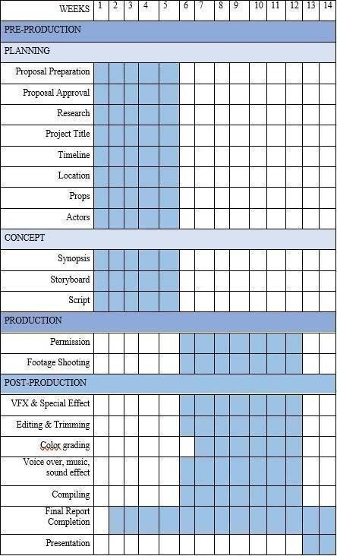

# 1.8 Conclusion

This chapter discusses our purpose for producing this short film and its objective. It also shows our Gantt Chart which our project will be done following the planning and the chart. The next chapter will be discussing the methodology of our project.

**CHAPTER 2**

**METHODOLOGY**

# 2.1 Introduction

In this chapter, we will explain the methodology that we used during our film production. There are three (3) phases for the progress which are pre-production, production, and postproduction.

## 2.2.1 Pre-production

In this process, our main focus is to deliver the idea and the planning throughout this film production. Below are a few processes that we did during the pre-production phase:

* Brainstorming idea

Each of our group members needs to come out with ideas for this film and the idea are presented to our supervisor, Dr. Mohd Adili during the meeting. In this meeting, our supervisor decided which ideas are the most suggested and give suggestions on what and how to improve the storyline. We also decided on our objective, title, and target audiences during this process.

* Planning

Task are distributed among team members during this process. The position is given to each team member based on each team member's capabilities and skills. Documentation also is done to list all the equipment and props, location, casting that are required for this film production. We also researched covid and bipolar disorder during this process.

* Storyboard and scripting

Team members will create a storyboard and scripting during this process. The script needs to be done first to make it easier to plan the type of shots when creating a storyboard. In the storyboard, we will describe the type of shots, the camera angle, the description of the environment, and the location.

# 2.2.2 Production

In this phase, we will start shooting. The camera angle, lighting, and the weather will be considered. The director is in-charge, during the production will give direction to the cast on how the cast should act and how the camera crew should film the shot. Director also give the lighting crew directions to light the shot and the stuntmen on what we needed to do following the storyboard that has been done previously. All the voiceover and also animation elements will be done at this stage.

## 2.2.3 Post-production

First, all the footage will transfer to an editing system that is Adobe Premiere Pro. Our editor will begin cutting the movie, guided by the vision of the director. Next, sound editors will assemble the audio tracks of a film, removing unwanted noise, and creating sound effects. When all audio tracks are finished, sound mixers step in to adjust audio levels. If the music is too loud while characters are speaking, the audience can’t hear what is happening. We will also go through every shot to digitally adjust and refine the hues and light to create continuity and strike a mood. Then, the Title, credits, and graphics are created and added. After all the editing has been done, the director will review the overall work.

## 2.3 Conclusion

To conclude, each of our team members is responsible to finish the 3 methodologies which are preproduction, production, post-production phase in time following the Gantt Chart in Chapter

1.

**CHAPTER 3**

**ANALYSIS REQUIREMENTS**

## 3.1 Introduction

Based on this project, we conducted the necessary research. There are certain parts of this film that need to be studied or examined, such as the current system, software, and hardware used for this filmmaking. To determine the user's requirements for this project, an analysis of user requirements will be conducted.

## 3.2 Analysis of Current System

In Malaysia, there is some news about mental health problems that are being affected by this pandemic such as when the government is asking people to stay at home and wear a mask when going outside from their home, people are easily getting bored by staying at home and also some of them disagree about wearing a face mask, face shield or even have to sanitize everything for their safety.

In terms of software, the software is a generic term for organized collections of computer data and instructions that are divided into two categories system software which provides the computer's basic non-task specific functions, and application software which is used by users to complete specific tasks. This film-making has been created in two stages throughout the project. They are divided into two categories which are development and documentation.

## 3.3 Analysis of Software Requirement

|  |  |
| --- | --- |
| **Software** | **Usage** |
| Adobe Animate and Adobe Flash | For making an animation. |
| Adobe Illustrator 2020 | For creating a poster, t-shirt, and some graphics in editing video. |
| Adobe Photoshop 2020 | For designing posters, t-shirt, and production logos for our team. Also used for distributing the storyboard. |
| Adobe Premiere Pro 2020 | For editing, combine all the footage and enhance the video quality. |
| Microsoft Word | For proposal and report preparation, write any ideas related to the storyline. Also, for scripting purposes. |
| Audacity | To record and edit audio. |

## 3.4 Analysis of Hardware Requirement

|  |  |  |
| --- | --- | --- |
| **Hardware** | **Usage** | **Source** |
| Laptop Asus Tuf Gaming FX505 **Specs:**   * **CPU:** AMD Ryzen 5 3550H * **RAM:** 12GB DDR4 * **GPU:** NVIDIA GeForce GTX 1050(2GB GDDR5) * **STORAGE:** 256GB SSD | To install and use software for editing all the video and audio. | Self-owned |
| Lighting | To support light sources. | Self-owned |
| Microphone | To record audio and give a better sound of the voice. | Self-owned |
| Tripod | To support cameras or smartphones during recording the video. | Self-owned |
| Sony ZV1    **Specs:**   * **Lens type:**   ZEISS® Vario-Sonnar® T* Lens, 10 elements in 9 groups (9 aspheric elements including AA lens)   * **Clear image**   **zoom(Movie):** 4K: 4.35x, HD:  Approx. 5.8x   * **Optical Zoom:** 2.7x | To record behind the scenes and raw footage of this drama. | Self-owned |

## 3.5 Analysis of User Requirement

For Workshop II, we provided a set of questionnaires and used it as the platform for research purposes to collect data from respondents. The survey is based on our project which is related to mental health. The main purposes we created a survey form to act as a guideline for our film. In this survey some respondents are not aware of symptoms for bipolar disorder. Hence, we will implement the symptoms in our film which is the script.

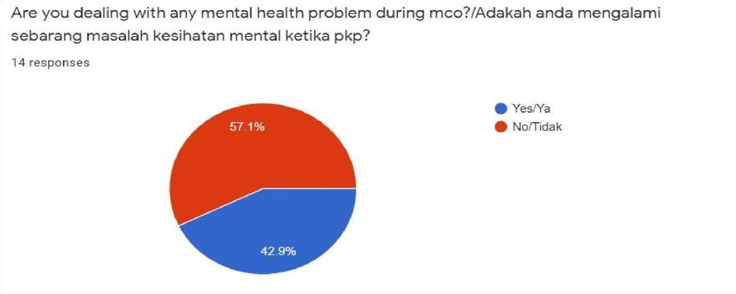



Figure 3.5.1

Based on figure 3.5.1, 57.1% of respondents face a mental health problem during MCO. We can conclude that MCO could cause mental health problems among the public. Hence, it corresponds to the theme and plotline of our film which in the film, the main character developed a mental disorder due to MCO.



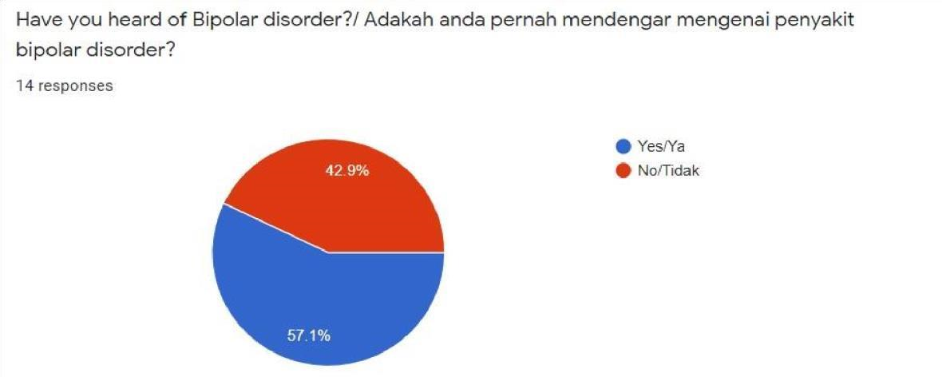

Figure 3.5.2

Based on the survey in Figure 3.5.2, we can see that 42.9% of respondents are not aware of bipolar disorder. Therefore, our group's main objective is to spread awareness about bipolar disorder to the public through this film.

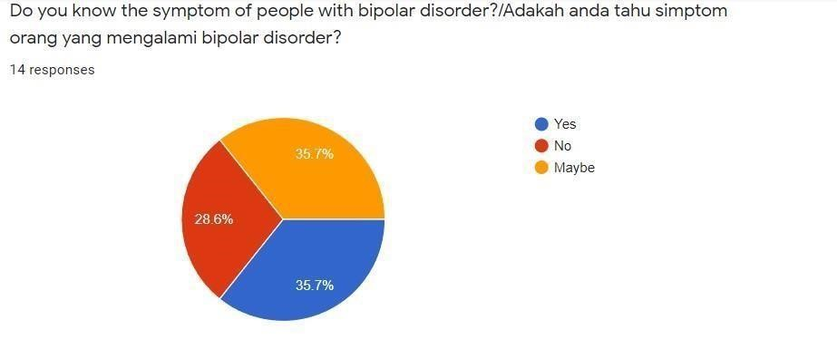

Figure 3.5.3

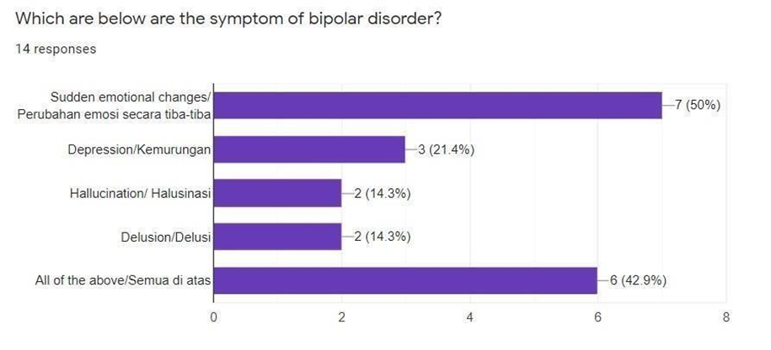

Figure 3.5.4

Based on figures 3.5.3 and 3.5.4, we can conclude that some respondents are not aware of symptoms for people with bipolar disorder. Sudden mood changes and depression are not the only symptoms of bipolar disorder. Some patients may have hallucinations and delusions as part of the symptom. Therefore, our group decided to apply the signs in our film to create awareness for the public.

Another focuses in our film is about covid-19. In this film, the audiences can learn accurate information about covid-19 and at the same time be able to create awareness among the public. So, the main purpose that we create this survey is for adding the knowledge to people who have never heard about bipolar disorder through our film.

## 3.6 Conclusion

In this chapter, we described all of the requirements and components, including software and hardware equipment that will be used in the production of this film. The purpose of stating all of these requirements is to serve as a guideline in the production of this film.

**CHAPTER 4**

**PRODUCT DESIGN**

## 4.1 Introduction

This chapter will go into the specify our short film's design. Our short film is in the drama category. In this chapter, we show our storyboard and the script for our film. This video, which has a maximum duration of 7 minutes, contains all of the media required to make our short film. We also attached the elements used, such as text, graphics, audio, and effects.

## 4.2 Media Collection

There are certain media collections that we applied in producing our short film by combining all of the multimedia materials in each scene of this film. The following are the media collections that were utilized to create this film:

|  |  |  |
| --- | --- | --- |
| **No.** | **Media elements** | **Sources** |
| 1. | Video | * All the footage is recorded by Sony ZV1 camera while editing the short film using Adobe Premiere Pro CC2020. * The format of the final video is “.mp4”. |
| 2. | Graphic | * Mostly the format of the graphics that we used is   “.jpg” and “.png” file. We use Adobe Photoshop CC 2020 and Adobe Illustrator CC 202 for editing.   * For animate graphics we edited using Adobe Animate and Adobe Flash. |
| 3. | Audio | * We amplified certain parts of this short film using Audacity. * We using “.mp3” file in order to import or export the audio. |
| 4. | Text | * Writing proposal, scripting, logbook and report are typed in Microsoft Word 2016. * All the text includes in our short film is used Adobe Premiere Pro CC 2020. |

## 4.3 Plot and Scene

**Scene 1**

|  |  |
| --- | --- |
| **Description**   * Main character, Alya and Rayyan meet a psychiatrist. * Rayyan tell Alya’s condition to psychiatrist. * Psychiatrist said that she can give Alya a medicine to relieve her pain. * Alya then had flashbacks to what really happened to her during the past month. | **Animation**   * **Z**oom in to Alya’s eye. |
| **Audio Visual**   * The voice of psychiatrist fade out. | **Graphic**   * In psychiatrist room. |

### Scene 2

|  |  |
| --- | --- |
| **Description**   * Alya’s father look at his phone about MCO article. * He switched off his phone. * He put “for rent/sale” sign on his shop. | **Animation**   * Hologram of article or news about MCO from the gadget |
| **Audio Visual**   * The noise of the city. | **Text**   * “Beberapa bulan yang lepas” come out. |
| **Graphic**   * The background at the shop.   A shop that is displaying a "for rent/sale" sign. | |

#### Scene 3

|  |
| --- |
| **Description**   * Alya’s father go to bank. * He wants to withdraw money from ATM machine. * He noticed that the balance is insufficient to withdraw. * He sighed and left the bank. |
| **Graphic**   * At the bank. * The screen of ATM machine that show the balance. |

#### Scene 4

|  |
| --- |
| **Description**   * Alya’s father just arrive. * He told to his wife that he lost his job. * He apologised to Alya because he cannot afford to pay for Alya’s studies. * Alya feels angry and upset with that. * Her mother did not want Alya to be rude to her father telling her to go to her room. |
| **Graphic**  • The background is in living room Alya’s house. |

#### Scene 5

|  |  |
| --- | --- |
| **Description**   * In this scene, it shows Alya upset with what have happen when her father tell that he cannot afford pay for her study. * She just sat and cry at her study table until she falls asleep. * His father gave her notes that contains a quote. * He gave through the hole in the door. * Alya read that note and cry. * Rayyan sent text to Alya because he worried about Alya condition and Rayyan invite Alya to meet at the park. | **Animation**   * Camera move in entire Alya’s room. |
| **Audio Visual**   * Alya crying. | **Graphic**   * The wall in Alya’s room full with sticky notes and info about studies. * The notes by Alya’s father. |

#### Scene 6

|  |
| --- |
| **Description**   * Rayyan and Alya go to park near their house. * Alya arrive first. * Suddenly, Hannah bumped Alya’s leg. * After that, Hannah started approach Alya by asking Alya if she okay or not. * Alya tells her problem that happen in her family to Hannah. * Hannah starts to agitate Alya. * Rayyan arrive and Alya introduce Hannah to Rayyan. * Rayyan feel strange about Alya because he did not see anyone with Alya at that time. * Alya also tells her problem about her father cannot afford to pay her study to Rayyan. * Rayyan give advice to Alya but Alya laugh all of sudden. * And she started talking nonsense about COVID-19 and vaccine. * When Rayyan attempted to fix the issue, Alya insisted and asked him to leave. |
| **Graphic**   * At the park. |

#### Scene 7

|  |
| --- |
| **Description**   * Hannah shows Alya blind people who ask for alms. Suddenly, she stole the money from the them. * Alya ask her why she stole that money. * Hannah says that she wants to help Alya to further her studies. |
| **Graphic**   * At roadside. |

|  |
| --- |
| **Description**   * Alya informed her parents the information on her phone concerning the COVID-19 vaccine's risks. * Her father said that he has already got an appointment date for the vaccine. * But after he saw the videos that Alya show to them, he feels unsafe to take the vaccine. * Her mother, who had begun to believe in the vaccination's effects, advised her husband not to go get the vaccination. * Hannah looked at Alya with a smile showing that Alya’s actions were right. |
| **Graphic**   * At sofa at living room Alya’s house. |

#### Scene 8

#### Scene 9

|  |  |
| --- | --- |
| **Description**   * Their neighbour came and show her mother a clip of Alya stealling the money from a burglar. * Then her mother shows it to her father and he suddenly collapse on the ground. * Alya panic when her father collapse. * Her father was taken to the hospital. * After that, the hospital tells Alya that her father passed away around 10.40pm because of COVID-19. * They also told her that her father had record of heart disease and it is supposedly got the vaccine. It is because it belongs to the high-risk group. | **Animation**   * An animation of her father collapsed from Ayah’s eyes. |
| **Audio Visual**   * Alya’s voice fade out. * Voiceover of the hospital when tell about her father is dead. | **Graphic**   * At Alya’s house. |

#### Scene 10

|  |
| --- |
| **Description**   * Alya brings Rayyan to empty house with “For rent/sell” sign. * Alya feel weird why that house like that. * Rayyan says that house is actually empty house. * Alya laugh as if she cannot believe what she saw. * Rayyan feel strange toward Alya and he ask Alya to follow him. He also brings Alya’s mother together. |
| **Graphic**   * At the empty house with “For rent/sell” sign. |

#### Scene 11

|  |  |
| --- | --- |
| **Description**   * End of flashback. * The psychiatrist tells all the symptoms that are being show by Alya is actually the symptoms of bipolar disorder. | |
| **Audio Visual**   * The sound of psychiatrists said to   Alya’s mother. | **Graphic**   * In psychiatrist room. |

|  |  |
| --- | --- |
| **Description**   * Alya flashback when her mother tells what actually triggered her father’s disease. * Alya wash her face and look at the mirror, she saw Hannah was smile at her. This is show that bipolar disorder does not have cure but can treat. * Alya broke the mirror after she saw Hannah. * End of flashback, psychiatrist voice says that Alya’s disorder have no cure but there is effective treatment. | **Animation**   * Hannah smiling at the other side in the mirror |
| **Audio Visual**   * Sound effect of a broken mirror. | **Graphic**   * In the toilet at Alya’s house. |

#### Scene 12

##### 4.4 Storyboard

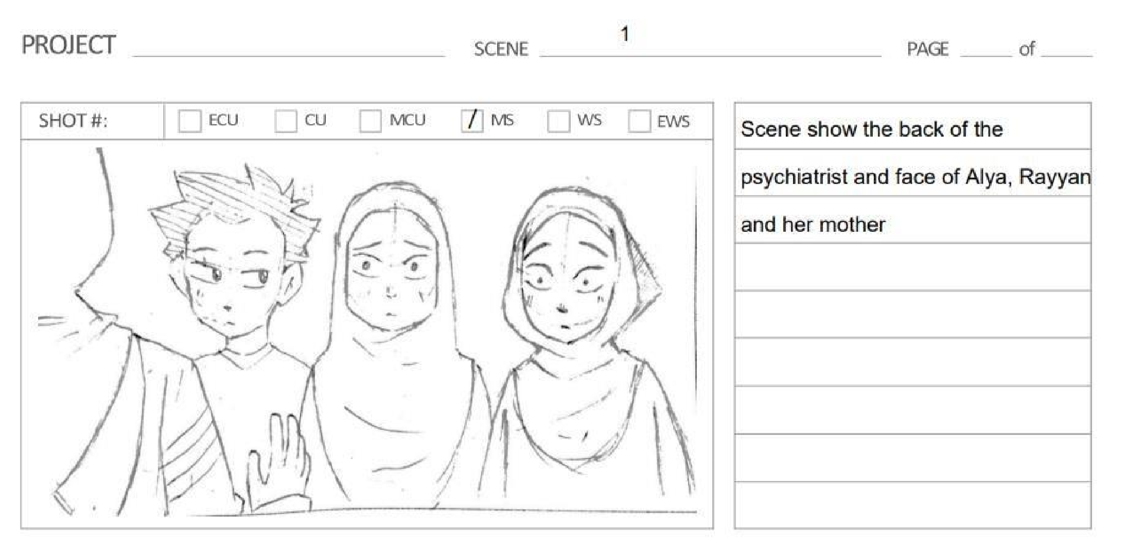

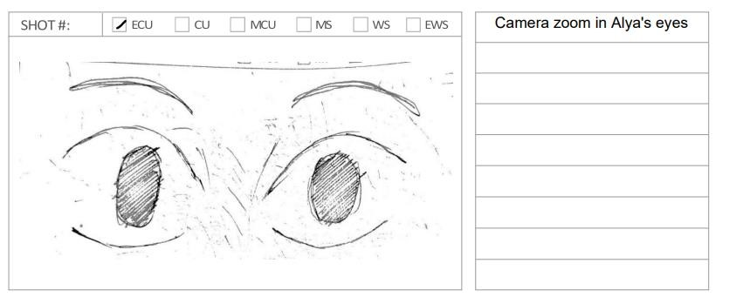



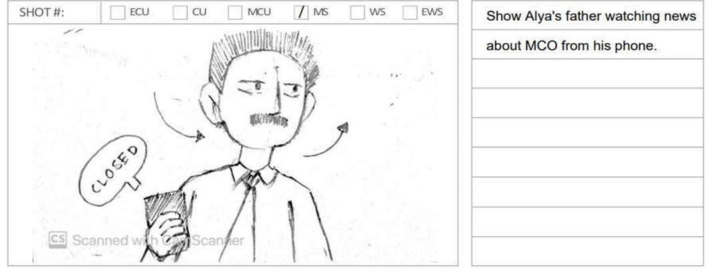

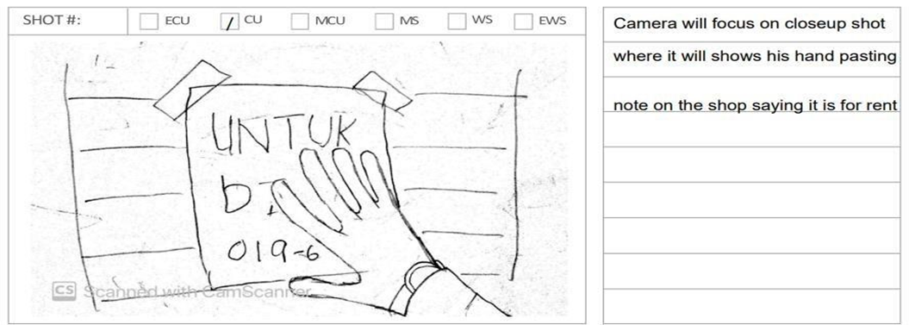



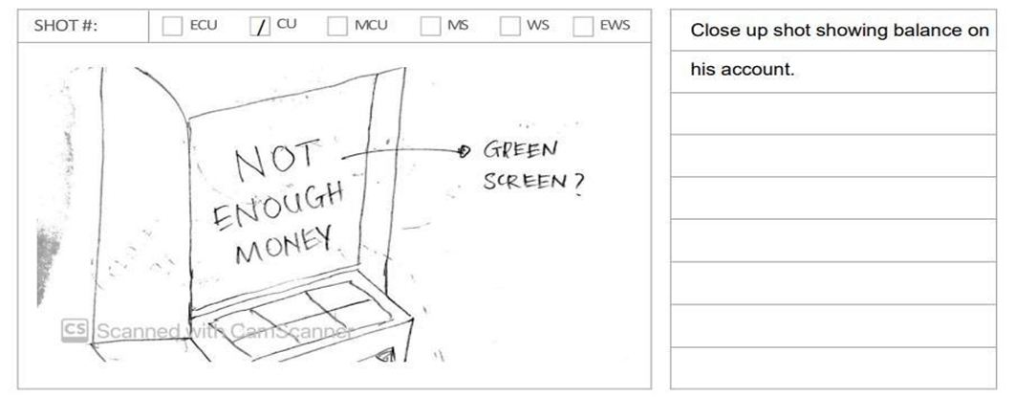



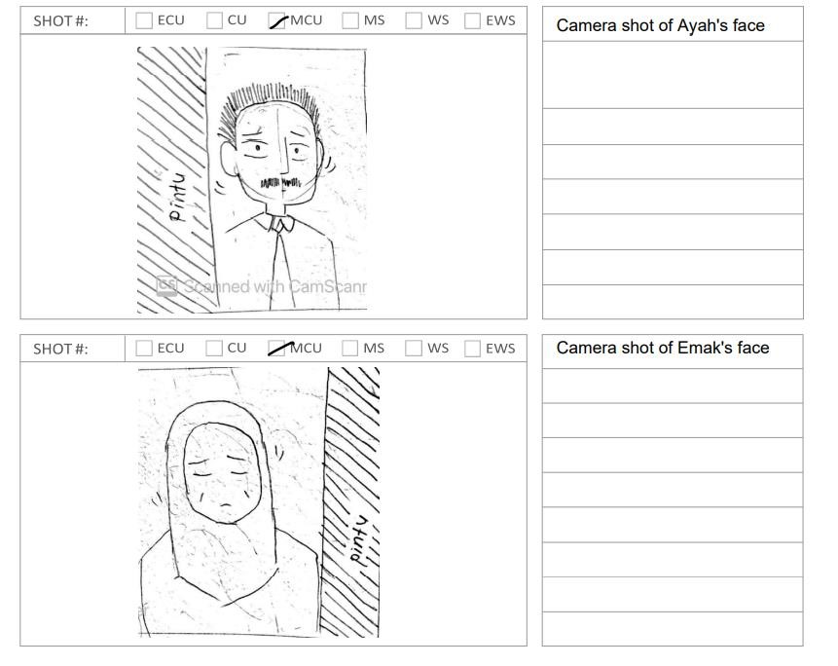

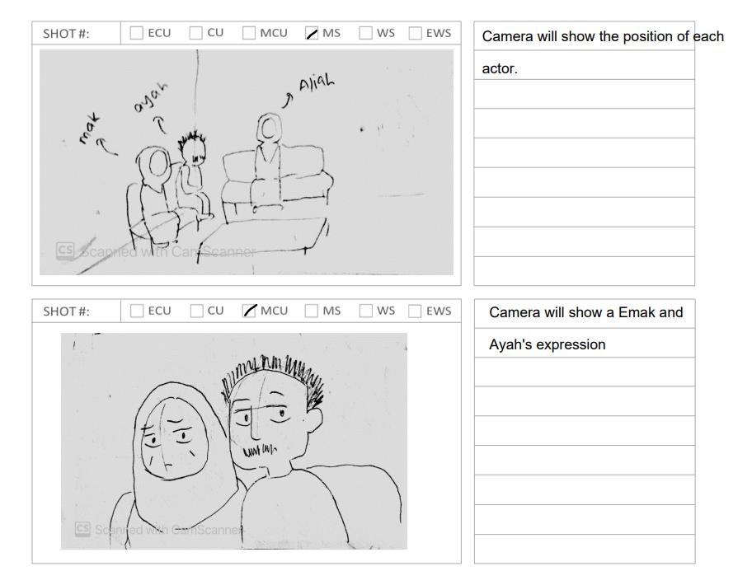

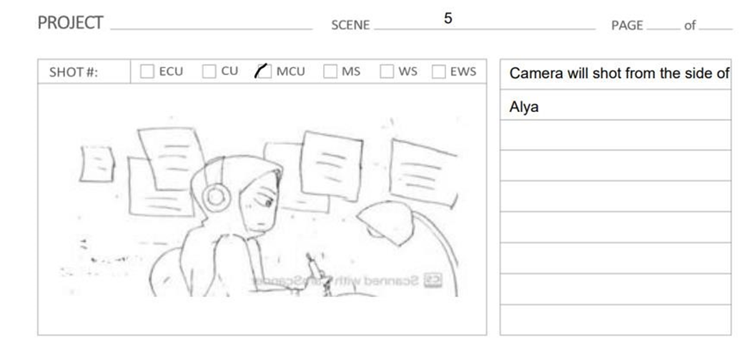

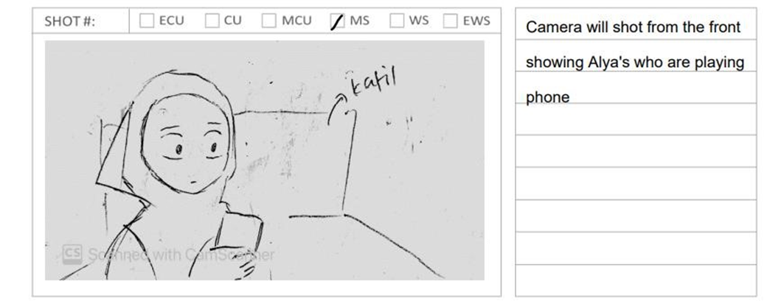

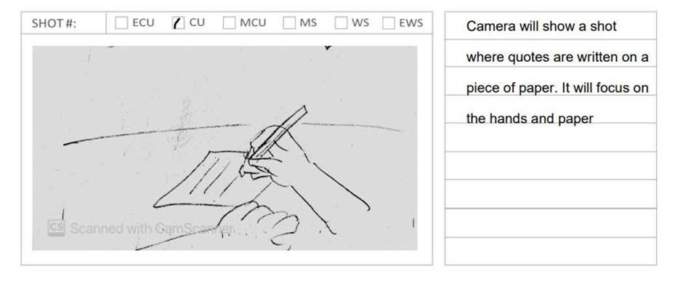

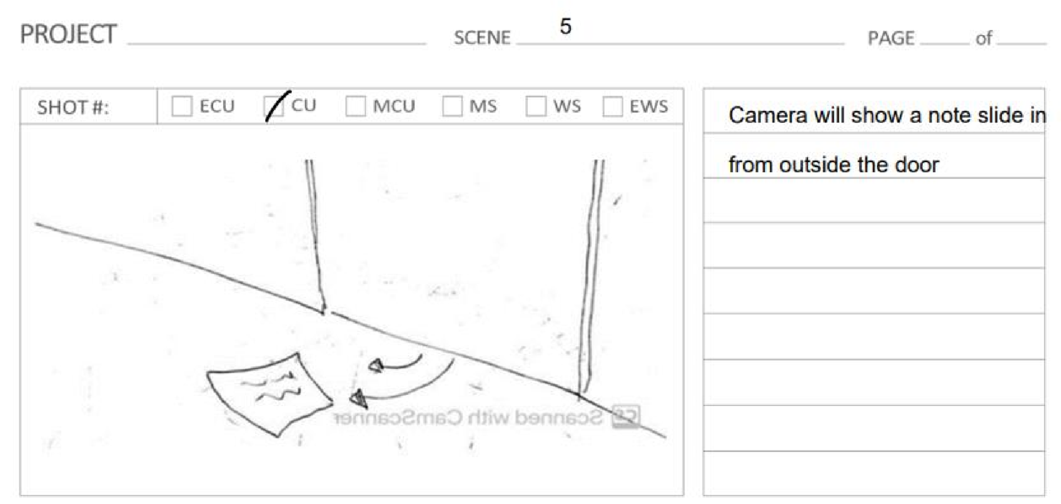



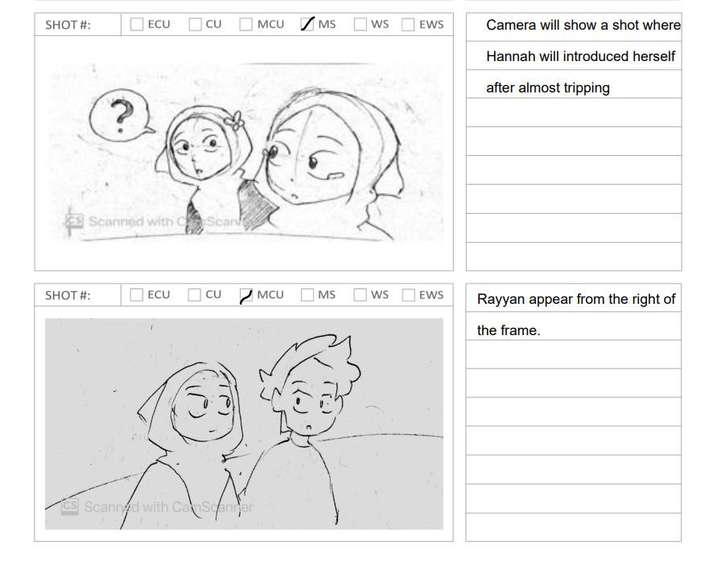

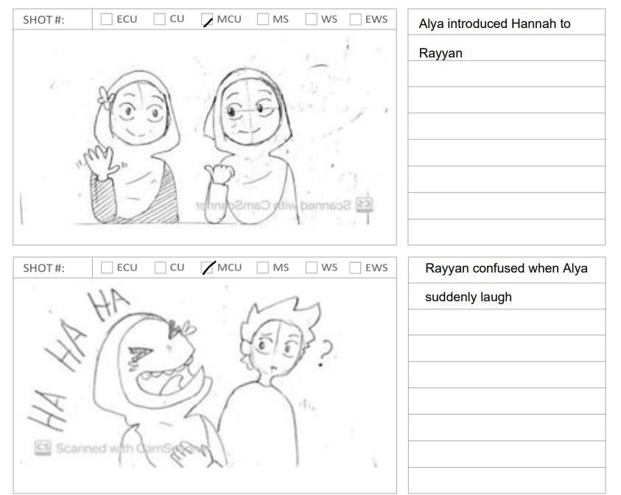

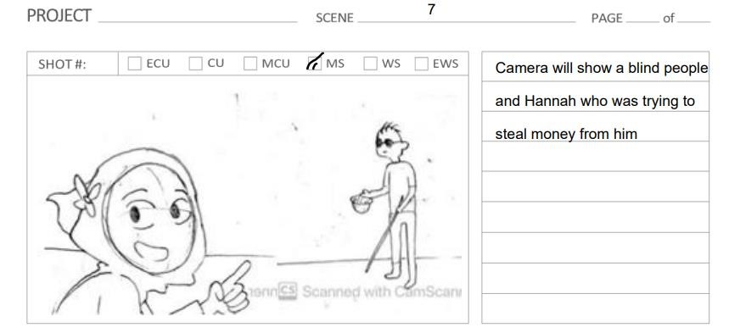

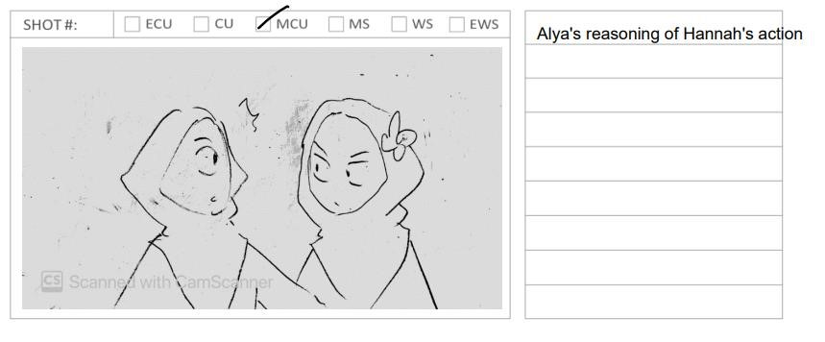

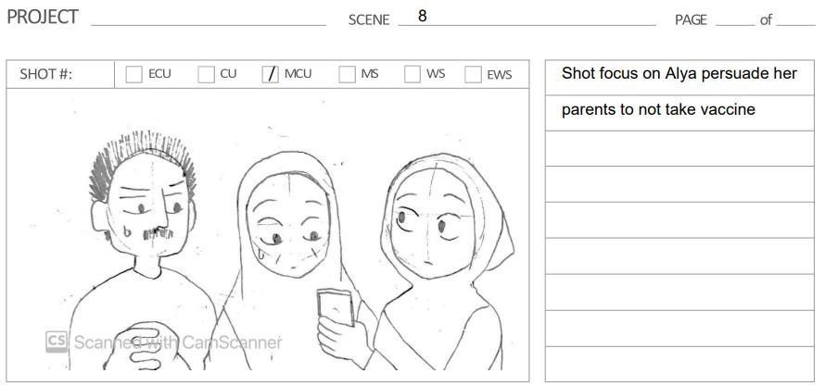

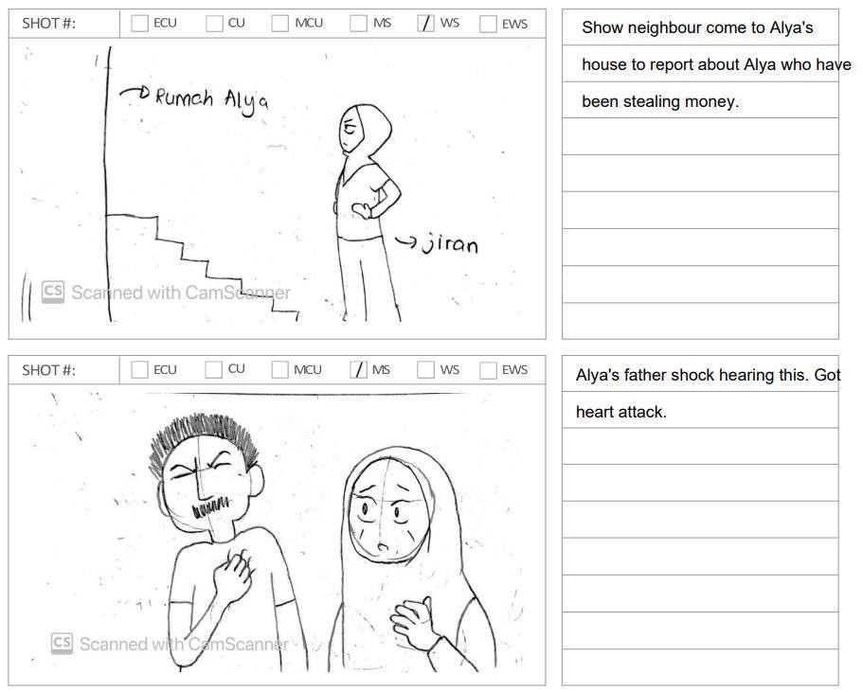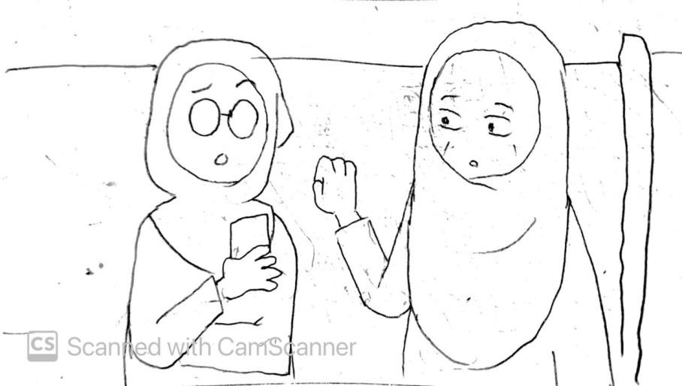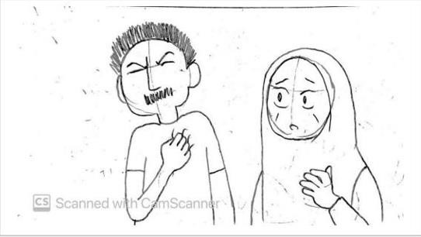



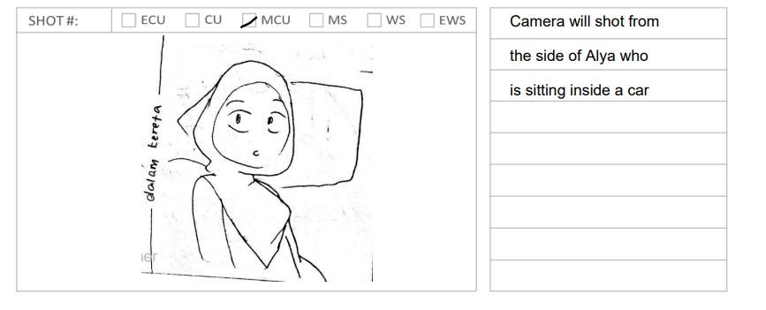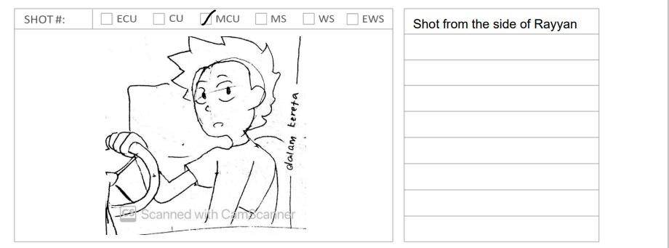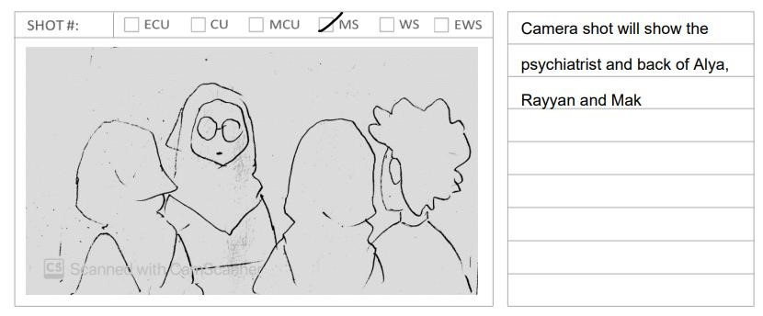

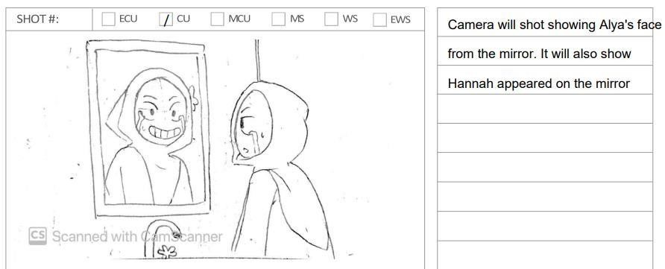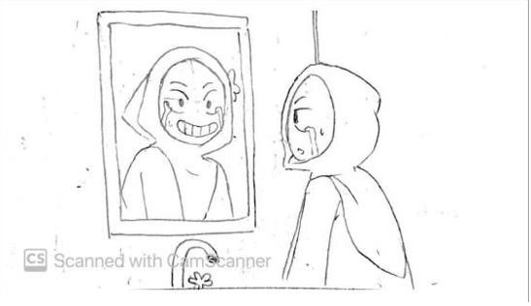

**4.5 Script Development**

There are two types of script for this film which are the Storyline script and the monologue script. The scripts are written in Malay. Music and the sound effects are included and editing used the Adobe Audition and After Effect.

|  |
| --- |
| **Scene 1**  *Place: Pejabat Psikiatri*  *Time: Pagi*  *Character: Rayyan, Alya dan Doktor*  *Scene ini tidak akan ditunjukkan muka psikiatri untuk beri unsur ingin tahu kepada penonton. Hanya wajah Mak,Alya dan Rayyan sahaja ditunjukkan*  Wanita : okay begini.. untuk sakit dia ni kita boleh bagi ubat untuk redakan sakit dia(suara fade out) .  Alya : *pegang perut menunjukkan rasa sakit*  Alya termenung dan scene mula zoom pada Alya : *mula flashback* |
| **Scene 2**  *Place: Tempat kerja*  *Time: Pagi*  *Character: Ayah*    *Ayah menutup screen telefon yang memaparkan berita pkp dilanjutkan *  * tempel notis kedai untuk dijual/disewa* |
| **Scene 3**  *Place: Bank*  *Time: Pagi*  *Character: Ayah*  *Scene menunjukkan ayah yang melihat akaun bank yang tidak mencukupi untuk keluar duit*  *Ayah mengeluh dan keluar dari bank* |
| **Scene 4**  *Place: Rumah*  *Time: Pagi*  *Character: Mak, Ayah dan Alya*    Mak : *buka pintu dan memandang ayah yang kelihatan murung *  Ayah : *menggeleng kepala untuk menunjukkan situasinya yang telah hilang pekerjaan*  *Mak hanya mengangguk faham*  *Alya sedang bermain telefon bimbitnya dan ayah datang duduk di sebelahnya*  Ayah : Alya..pasal kamu nak sambung degree tu ..ayah minta maaf. Tapi keadaan kita tak berapa nak mengizinkan.  Alya : tapi ayah… ayah tahu kan Alya nak jadi..  Mak : Alya .. dah. pergi masuk ke bilik kamu sekarang.  Alya : *berjalan masuk ke bilik sambil menghentak kaki* |
| **Scene 5**  *Place: Bilik tidur*  *Time: Malam*  *Character: Alya, Ayah dan Mak*  *Alya berada di meja belajar dan kamera menunjukkan keadaan bilik yang penuh dengan sticky notes tentang pelajaran dan info tentang degree*  Alya : *menangis sehingga tertidur di meja belajar*  Ayah : *memberi quotes/kata2 yang ditulis ayah lalu diberi melalui lubang pintu Alya*  “Langit tak selalu cerah. Awan pula tak selalu mendung. Selepas malam, pasti datangnya siang. Selepas ujian, pastinya ada nikmat menanti”  *Alya membaca sambil menangis*  Rayyan : *hantar mesej ke Alya : Aku risaulah dengar cerita kau tak keluar bilik beberapa hari .. Jom jumpa dekat taman aku nak bagi something* |
| **Scene 6**  *Place: Taman*  *Time: Petang*  *Character: Hannah, Alya dan Rayyan*    *Alya termenung sambil menunggu Rayyan*  *Hannah terlanggar kaki Alya*    Hannah: Eh sorry.. jap kenapa mata kau macam baru lepas nangis? Kau ok ke? By the way, Aku Hannah and baru je pindah dekat rumah hujung taman.  Alya: Hi, aku Alya. Rumah kosong tu eh. Aku ada masalah family sikit sejak covid ni. Hannah: Kau percaya covid ni? Aku tengok kan dekat internet, covid ni salah satu rancangan NWO untuk depopulasikan manusia. So bila orang percaya pasal covid, diaorang terpaksa ambil vaksin. Tu yang ambil vaksin ada yang mati tu. Lagi satu *sambil buang mask Alya* kalau pikir logic pakai mask je boleh elak covid? Aku rasa covid ni tipu je.. jangan risaulah takda benda yang nak ditakutkan. Ni semua ideology media barat je.    *Rayyan tiba-tiba muncul*    Rayyan: Sorry lambat. ada hal.Nah untuk kau..  Alya : Lah.. macam tahu2 ja aku suka chocolate .. Susah-susah ja..  Rayyan : No problemlah.. kau kan bestfriend aku.  Alya: oh ya.. By the way, perkenalkan kawan baru aku, Hannah.    *Hannah melambai ke Rayyan*  Rayyan: Kawan? Pandai kau bergurau. Eh! Keadaan kau macam mana?  Alya: *mula menangis* Aku stress la. Aku terpaksa berhenti belajar sebab ayah aku tak mampu tanggung dah.  Rayyan: aku faham...tapi kau kena faham situasi family kau sekarang ni. Ibu bapa mana yang tak nak tengok anak dia berjaya. kadang-kadang Tuhan berikan ujian kepada hamba dia supaya kita kembali padaNya, menangis macam ni bukan caranya.  Berdoa pada Dia. Dia sebaik-baik perancang.  Alya : *ketawa*  Rayyan: Eh gelak pulak.  Alya: Ni semua sebab covid. Aku tak percaya covid ni. Kawan aku bagitahu(sambil pandang ke arah Hannah) covid vaksin tu semua ideology dri NWO untuk hapuskan populasi manusia.. aku rasa ada betul juga sebab..  Rayyan : seriusla.. apa benda yang kau merepek ni. Kau fikir orang yang kene covid dekat hospital tu saja-saja nak masuk hospital?  Alya : oh sekarang ni kau nak cakap yang aku ni mengarutlah? ish dahla susah la cakap dengan kau ni !!.. apa yang aku cakap bagi kau semua tak betul..kau balik lah!!  Rayyan : Alya aku cuma..  Hannah : Dah kau balik sekarang..    *Rayyan pulang tinggalkan Alya dan tiba-tiba Hannah berbisik sebelah Alya*    Hannah :biasalah tu. Dah kena *brainwashed* dengan media barat.  Alya : Ah dahlah aku nak balik. eh nak ikut aku balik rumah tak? Boleh lepak-lepak kat rumah aku.  Hannah :ha boleh ! Jomlah. |
| **Scene 7**  *Place: Di tepi jalan*  *Time: Pagi*  *Character: Hannah dan Alya*  Hannah : Eh kau tengok orang buta tu minta sedekah.. kau tunggu sini jap *Hannah mencuri duit orang buta itu*  Alya : weh kau curi duit dia kenapa?  Hannah : aku nak tolong kau ok? Aku kesian la tengok kau tak boleh sambung study sebab takda duit.. so ni duit untuk bantu kau nanti.  Alya : ok |
| **Scene 8**  *Place: Ruang tamu*  *Time: Pagi*  *Character: Ayah dan mak*  *Alya menunjukkan phone nya kepada mak dan ayah mengenai keburukan vaccine.  Scene ni tidak mempunyai dialog hanya aksi.*  *Masuk suara ayah*    Ayah: ayah dah daftar vaksin tu dan tarikh cucuk vaksin harini. Tapi bila tengok video kamu tunjuk ni dengan yang ayah dapat dari kawan-kawan ayah jadi takut pula.  Mak: Macam tu kita tak payah pergilah bang. |
| **Scene 9**  *Place: Ruang tamu*  *Time: Petang*  *Character: Ayah, Jiran, Mak, Alya dan Staf hospital*  *2 HARI KEMUDIAN*  *Jiran datang ke rumah Alya untuk mencari ibubapanya untuk melaporkan perbuatan mencuri Alya. Jiran menunjukkan bukti bahawa Alya mencuri. Scene ini Alya berada di bilik *  Jiran : Eh Mira. Ini anak kau kan ? Alya ? *sambil menunjukkan klip video*  Mak : Eh Alya ke ni ? Bang ! Abang ! Alya ke ni ?  Ayah : Eh *memegang badan bahagian jantung dan pengsan*  Mak ; Alya ! Alya !  Alya : AYAH !! AYAH !!  *suara fade out sambil scene menunjukkan situasi kalut*  Ayah: *POV* (dari mata Ayah screen menjadi gelap)  Pihak hospital *voiceover* : Maaf cik, ayah encik disahkan meninggal dunia dalam pukul 10.40 malam disebabkan covid positif. Berdasarkan rekod kesihatan, ayah cik ni mempunyai sejarah penyakit jantung dan virus akan merosakkan bahagian saluran saraf jantung. Ayah cik juga tidak mempunyai rekod vaksin, golongan seperti ini mempunyai risiko yang tinggi menghidapi kes kritikal jika dihidapi virus covid ini. Saya rasa ada sesuatu yang triggered penyakit jantung ayah encik. |
| **Scene 10**  *Place: Rumah kosong*  *Time: Pagi*  *Character: Alya dan Rayyan*  Alya : Eh kenapa untuk disewa pula rumah dia? Rayyan : rumah ni memang dah lama kosong.  Alya : *ketawa* dahtu? Kau nak cakap yang selama ni aku tipu kau? Dahtu takkan selama ni aku cakap sorang-sorang?  Rayyan: *memandangnya pelik* Kau ni lately memang pelik .Kau ikut aku.  Alya : pergi mana pulak..  Rayyan : ah ikut ja.. kita bawak mak kau sekali. |
| **Scene 11**  *Place: Hospital*  *Time: Tengahari*  *Character: Doktor psikiatri*  *habis flashback*  *Kembali pada suasana bilik psikiatri pada scene 1*    Psikiatri: Begini Puan, berdasarkan daripada semua symptom yang ditunjukkan cik Alya, cik Alya ni mempunyai penyakit yang dikenali sebagai bipolar disorder.. Bipolar disorder merupakan salah satu masalah gangguan mental. Bipolar Disorder adalah penyakit mental yang melibatkan perubahan emosi yang melampau. Ada sesetengah patient yang mengalami psychosis dimana pesakit boleh mengalami halusinasi dimana dia membayangkan sesuatu yang tidak wujud. So, kita akan buat appointment untuk rawatan seterusnya. |
| **Scene 12**  *Place: Dalam tandas*  *Time: Malam*  *Character: Alya dan Hannah , Mak*  *flashback*  Mak: sebenarnya apa yang triggered penyakit jantung ayah tu selepas dia tahu perbuatan mencuri kamu ..  Alya : * mendongak dan ternampak Hannah senyum pada dia.* (simbolik kepada penyakit bipolar disorder tidak dapat disembuhkan) *Alya memecahkan cermin*  Alya : Jadi.. Hannah tu.. aku? |

## 4.6 Conclusion

This chapter shows the way of this film will be making and all the scripts are written in Malay.

The camera movement, the audio and sound effects are include.

**CHAPTER 5**

**THE IMPLEMENTATION OF PRODUCT DEVELOPMENT**

## 5.1 Introduction

This chapter will explain about the tools and software that we used to create the text, videos, audio, image and animation during the production of our film.

## 5.2 Production and Implementation

### 5.2.1 Text Production

Adobe Premiere Pro CC 2020 is used for the text production. The fonts for the subtitle are Arial, white and small.

### 5.2.2 Graphic Production

Adobe Illustrator CC 2020 and Adobe Photoshop CC 2020 is used for the graphic production. The design are including logo, poster, thumbnail and Tshirt design. The format for the graphic are “.jpg/ .jpeg” and “.png” format.

**5.2.3 Audio Production**

Audacity and Adobe Audition CC 2020 are used to edit and trim the sound for the short film.

### 5.2.4 Video Production

To edit the footage and video such as trim the video, insert a transition, we used Adobe

Premiere Pro CC 2020. Adobe After Effects CC 2020 is also used for the effects in the video.

### 5.2.5 Animation Production

Adobe Premiere Pro CC 2020 and Blender are used to produce the 3D animation in the video.

The animation in logo created using Adobe After effect 2020.

## 5.3 Integration Process (All Production)

All of the elements for the video is compiled and done using Adobe Premiere Pro CC 2020. This includes editing and arranging all the scenes and audio into a sequences. The final output will be exported into MP4 format.

## 5.4 Conclusion

In conclusion, all the software and tools that being used in this film production are explained in this chapter. The next chapter will discuss about the product usage and evaluation.

**CHAPTER 6**

**PRODUCT TESTING AND EVALUATION**

## 6.1 Introduction

The topic of product testing and evaluation will be covered in this chapter. Every product we make must go through a testing phase. After the recording and design phases are completed, the testing phase will begin. During this process, it will be determined whether or not the product may be promoted. This phase will be carried out during the 14th week of the presentation. Because the country is now under pandemic COVID-19, the testing will be done online.

## 6.2 Product Testing

This is the stage at which the video will be reviewed to see whether the video quality and message provided are appropriate. This is required to ensure that the video is of good quality. Our teams and our supervisor are the one who are involved in this testing process. The table shows viewpoints on the various forms of system testing and who is included during this phase.

|  |  |
| --- | --- |
| **Types of Testing** | **People That Involved** |
| a. Instructional Design Testing   * Video pace * Media elements | * Our teams * Supervisor |
| b. Technical Quality Testing   * Picture quality * Sound quality * Production style * Animation quality | * Our teams * Supervisor |
| c. Purpose and Intend Testing   * Message of the video | * Supervisor |

## 6.3 Product Evaluation

|  |  |  |
| --- | --- | --- |
| **No.** | **Aspects** | **Results** |
| 1. | Poster, T-shirt design and DVD cover | Good |
| 2. | Production logo watermark | Good |
| 3. | Audio sound quality | Good |
| 4. | Video quality | Good |
| 5. | Text display | Good |
| 6. | 3D graphic display | Good |
| 7. | Animation workflow | Good |

## 6.4 User Acceptance

Once the testing and evaluating phases are confirmed, we will wait for feedback from our audience to determine whether or not the video fulfilled their expectations. After the testing and evaluation stages are completed, the product has passed. In the stage of development, product quality and an attractive trailer are the most important factors in attracting audiences since they favour high-quality products.

## 6.5 Result Analysis

Based on the results of the testing and evaluation, it is clear that the product was well-made and free of issues. The video development process is going well and without problem. Furthermore, this film has satisfied all of the requirements that have been established. For the best view and results, the video's highest resolution was used.

## 6.6 System Constraint

When making this short video, there were several constraints. We must manage our time wisely since we have a limited amount of time to create a high-quality and attractive film. The weather might be a concern during the filming period since it delays the recording of the video. Also, in order to maintain the video's quality. The most difficult challenge we had was finding extra actors to collaborate with us.

## 6.7 Conclusion

Overall, this chapter decides whether or not the product will be produced. The product will undergo the production phase after all of the criteria have been met.

**CHAPTER 7**

### CONCLUSION AND RECOMMENDATION

#### 7.1 Introduction

In this chapter will go through the conclusion, recommendations for improving the video's quality.

#### 7.2 Achievement

The quality of the videos is very important for every member in this group so we plan meticulously and ensure that the plan and process are followed. Apart from the audio, the video and the after effects are of high quality are having been checked and evaluated by our editor in this group. We are using Adobe Premiere Pro and Adobe After Effects for the video editing and for the effects. Audacity are being use to edit the audio for the video. Furthermore, because the day of the filming is varied, some parts of the video are not connected naturally, and the transition and effect are missed. In order to solve this problem, editing are heavily done in order to produce a quality videos. Overall, this short film might send a message to the viewers encouraging them to learn from others' mistakes.

#### 7.3 Recommendation

In order to improve the quality of video and to ensure time is not dragging during filming, we need to pay close attention to the lighting before shooting. Aside from that, the scripts need to be memorised beforehand by the actor to avoid time delay during shooting. Weather also need to be concerned about and must check before the day of shooting. Therefore, we can plan out our shooting day and times based from the weather condition. We should also pay a bit more attention to the transitions and effects in the video's scenes.

#### 7.4 Conclusion

To conclude, we meet the objective and goal of making the short film. Our production team, Crewrona Production team have worked really hard into this short film and brave enough to try new things and never be scared to make mistakes. The most significant aspect is that the production of this short film was made possible thanks to the collaboration of all team members. Finally, the short film tittled Khayalan was completed successfully.

**REFERENCES**

*Bipolar Disorder*. (2020). National Institute of Mental Health (NIMH). https://www.nimh.nih.gov/health/topics/bipolar-disorder

*Bipolar disorder - Symptoms and causes*. (2021, February 16). Mayo Clinic.

[https://www.mayoclinic.org/diseases-conditions/bipolar-disorder/symptoms-causes/syc-](https://www.mayoclinic.org/diseases-conditions/bipolar-disorder/symptoms-causes/syc-20355955)

[20355955](https://www.mayoclinic.org/diseases-conditions/bipolar-disorder/symptoms-causes/syc-20355955)

*What Are Bipolar Disorders?* (2020). Web Starter Kit. https://www.psychiatry.org/patientsfamilies/bipolar-disorders/what-are-bipolar-disorders